**Sitemap**

1. So, for the homepage I am going to show customer how to find and reserve rooms in our hotel and two links show customer events in our hotel, and a link to about us where customer can view information about our hotel.
2. Side page has a lookup tool allowing customer to select which hotel they want to go and allow customer to select check-in dates and room selecting.

3. I have two side pages which tell customer what events are holding recently for example, wedding, group travel and business meeting etc. and specific instructions tell customer how to sign in and become membership in our hotel. Finally, our hotel overview.

**Photos**

**1.**

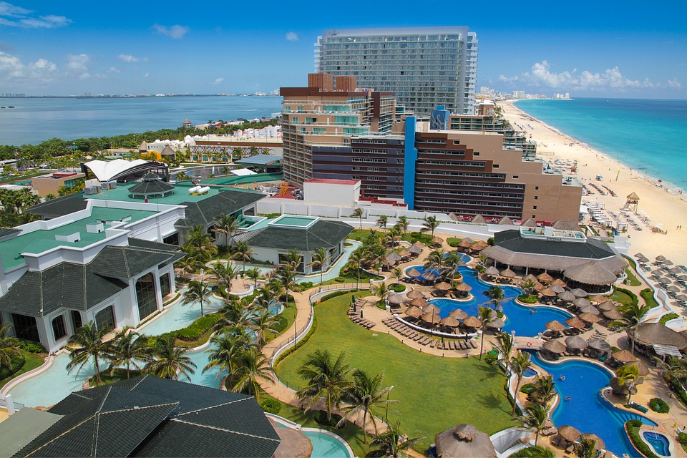

**2.**

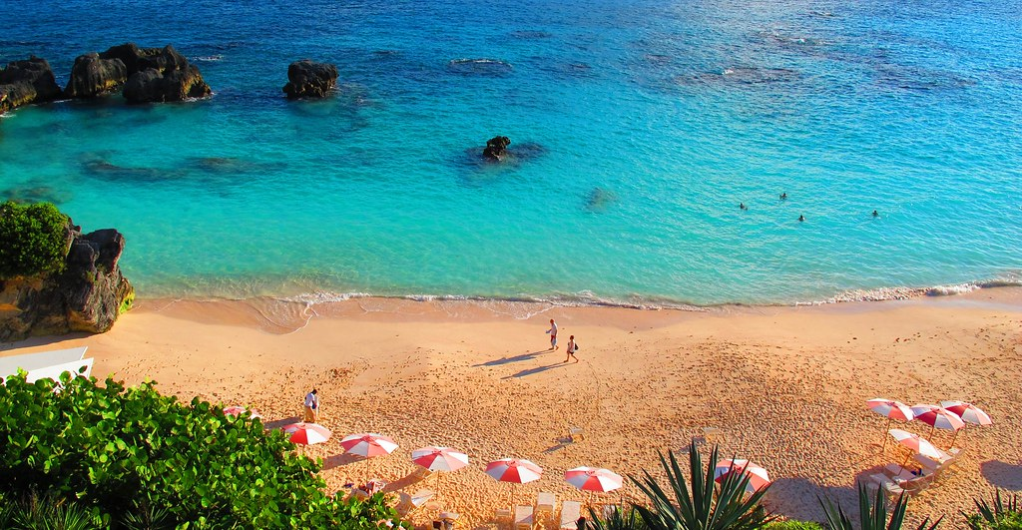

**3.**

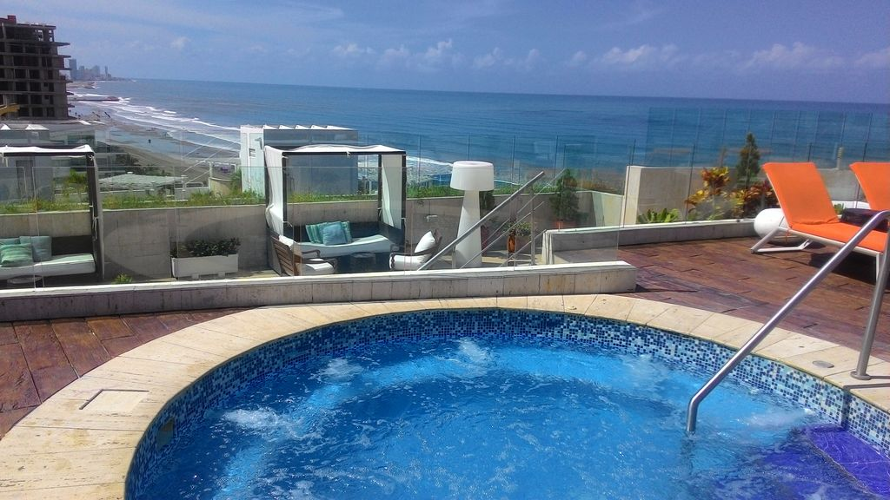

**4.**

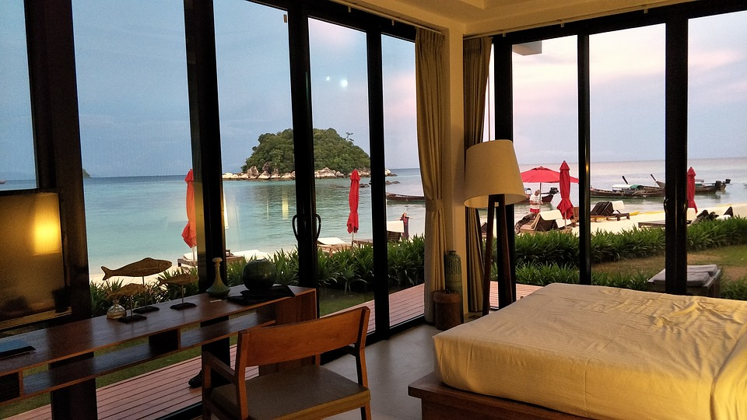

|  |  |  |  |  |
| --- | --- | --- | --- | --- |
| **Picture 1** | **Picture 2** | **Picture 3** | **Picture4** | **Audio** |
| **Hotel image** | **Hotel image** | **Hotel image** | **Hotel image** | **Background music** |
| **Google images** | **Google images** | **Google images** | **Google images** | **Youtube** |
| <https://pixabay.com/photos/holidays-the-hotel-beach-pool-sea-2772361/> | <https://www.flickr.com/photos/gotobermuda/6821713936> | <https://www.wcifly.com/en/travel-cartagena-colombia> | <https://www.maxpixel.net/Room-Beach-View-Beach-View-Room-Beach-Thailand-Beach-2483881> | <https://www.youtube.com/watch?v=uTcSXdB9eS8> |
| **Labeled for noncommercial with modification** | **Labeled for noncommercial with modification** | **Labeled for noncommercial with modification** | **Labeled for noncommercial with modification** | **Labeled for noncommercial with modification** |